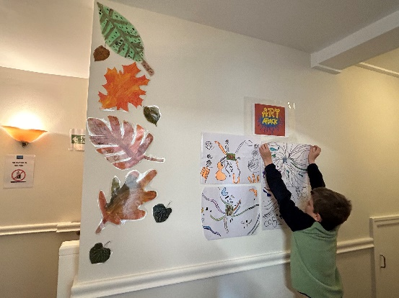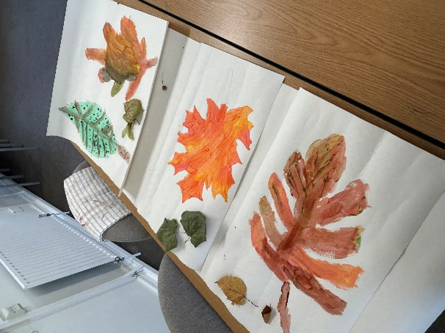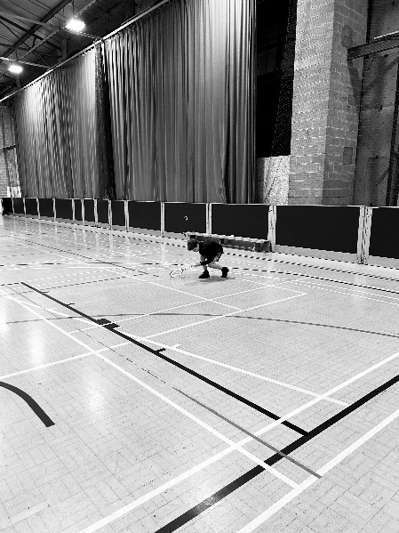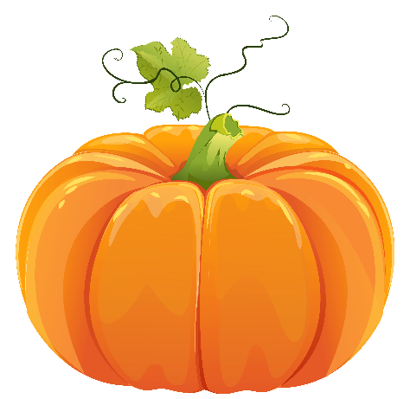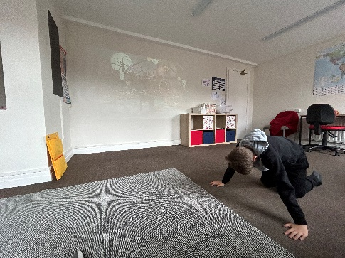

***\*\*Please remember appropriate clothing on Wednesdays for PE/outdoor education***

Creating our art display

Badminton

Nature themed art work

**Dates for your diary:**

* Break up for October half term **Friday 18th October** at 12pm
* Back in school **Monday 4th November**

Issue 1

Halloween themed yoga on a rainy PE day

**Message from the owners**

Hello and welcome to issue one of our newsletter. We would like to take this opportunity to say hello to our parents, carers, referring schools and agencies.

What a half term we’ve had! From our core subjects of Maths and English to outdoor education and much more. This half term we have read and analysed stories, applied our mathematical knowledge to every day scenarios, been swimming, played badminton, done yoga, looked at nature, the human body, been on visits in the local community and much more.

As we head into the half term break, we wish you a spooktacular Halloween and look forward to seeing you back in school on Monday 4th November.

Elle and Tash 😊

Refresh Education newsletter October 2024