WHISTLE – BLOWING POLICY

Aim

Employees are often the first to realise that there may be something seriously wrong within the school. However, they may be reluctant to express their concerns because they feel that speaking up would be disloyal to their colleagues or to the school. They may also fear harassment or victimisation.

In these circumstances, it may be easier to ignore the concern rather than report what may just be a suspicion of malpractice. Refresh Education is committed to the highest possible standards of openness and accountability. In line with that commitment, we expect employees, and others that we deal with, who have serious concerns about any aspect of the school's work to come forward and voice those concerns. It is recognised that most cases will have to proceed on a confidential basis.

This aim of this policy document is to ensure that clear that staff can voice concerns without fear of victimisation, subsequent discrimination or disadvantage.

This whistle-blowing policy is intended to encourage and enable employees to raise serious concerns within the school rather than overlooking a problem.

The policy applies to all employees and those contractors working for the school, on school premises, for example, agency staff. It also covers suppliers and those providing services under a contract with the school in their own premises.

These procedures are in addition to the school's complaints policy.

Scope of this policy

This policy aims to:
• encourage you to feel confident in raising serious concerns and to question and act upon concerns about practice
• provide avenues for you to raise those concerns and receive feedback on any action taken • ensure that you receive a response to your concerns and that you are aware of how to pursue them if you are not satisfied
• reassure you that you will be protected from possible reprisals or victimisation if you have a reasonable belief that you have made any disclosure in good faith.

The whistle-blowing policy is intended to cover major concerns that fall outside the scope of other procedures. These include:

• conduct which is an offence or a breach of law
• disclosures related to miscarriages of justice
• health and safety risks, including risks to the public as well as other employees
• damage to the environment
• the unauthorised use of public funds
• possible fraud and corruption
• sexual or physical abuse of students, or
• other unethical conduct Thus, any serious concerns that you have about any aspect of service provision or the conduct of officers or members of the academy or others acting on behalf of the academy can be reported under the whistle-blowing policy.

This may be about something that:
• makes you feel uncomfortable in terms of known standards, your experience or the standards you believe the school subscribes to; or
• is against the schools policies; or
• falls below established standards of practice; or
• amounts to improper conduct.

This policy does not replace the school complaints procedure.

Safeguards

Harassment or Victimisation

The school is dedicated to upholding good practice and maintaining high standards while also providing support to its employees. Recognising that reporting concerns can be challenging, the school encourages honesty and integrity. Employees should feel assured that if they speak truthfully, they have nothing to fear as they are fulfilling their duty to their employer and the individuals they serve.
The school unequivocally opposes any form of harassment or victimisation, including informal pressures, and will take necessary measures to safeguard employees who raise concerns in good faith.
Any investigation into allegations of potential wrongdoing will remain independent of ongoing disciplinary or redundancy procedures affecting the individual involved.

Confidentiality

All concerns will be treated in confidence and every effort will be made not to reveal your identity if you so wish. At the appropriate time, however, you may need to come forward as a witness.

Anonymous Allegations

This policy encourages you to put your name to your allegation whenever possible. Concerns expressed anonymously are much less powerful but will be considered at the discretion of the school.
In exercising this discretion, the factors to be considered would include:
• the seriousness of the issues raised
• the credibility of the concern;
• the likelihood of confirming the allegation from attributable sources.

Untrue Allegations

If you make an allegation in good faith, but it is not confirmed by the investigation, no action will be taken against you.
If, however, you make an allegation frivolously, maliciously or for personal gain, disciplinary action may be taken against you.

How to raise a concern

As a first step, you should normally raise concerns with your immediate manager or their superior. This depends, however, on the seriousness and sensitivity of the issues involved and who is suspected of malpractice.

For example, if you believe that management is involved you should approach the Headteacher or School Business Manager.

Concerns may be raised verbally or in writing. Staff who wish to make a written report are invited to use the following format:
- the background and history of the concern (giving relevant dates);
- the reason why you are particularly concerned about the situation. The earlier you express concern the easier it is to take action.
- Although you are not expected to prove beyond doubt the truth of an allegation, you will need to demonstrate to the person contacted that there are reasonable grounds for your concern.
- You may invite your trade union, professional association representative or a friend to be present during any meetings or interviews in connection with the concerns you have raised.

How the school will respond

Where appropriate, the matters raised may:
• be investigated by management, or through the disciplinary process
• be referred to the police
• be referred to the external auditor
• form the subject of an independent inquiry.

In order to protect individuals and those accused of misdeeds or possible malpractice, initial enquiries will be made to decide whether an investigation is appropriate and, if so, what form it should take.
Some concerns may be resolved by agreed action without the need for investigation.
If urgent action is required, this will be taken before any investigation is conducted.

Within ten working days of a concern being raised, the responsible person will write to you: • acknowledging that the concern has been received
• indicating how we propose to deal with the matter
• giving an estimate of how long it will take to provide a final response
• telling you whether any initial enquiries have been made
• supplying you with information on staff support mechanisms, and
• telling you whether further investigations will take place and if not, why not.

The amount of contact between the officers considering the issues and you will depend on the nature of the matters raised, the potential difficulties involved, and the clarity of the information provided.
If necessary, the school will seek further information from you. Where any meeting is arranged, off-site if you so wish, you can be accompanied by a union or professional association representative or a friend.
The school will take steps to minimise any difficulties which you may experience as a result of raising a concern. For instance, if you are required to give evidence in criminal or disciplinary proceedings the school will arrange for you to receive advice about the procedure.
The school accepts that you need to be assured that the matter has been properly addressed. Thus, subject to legal constraints, we will inform you of the outcome of any investigation.

Proprietors & management ( Head Teacher / School Business Manager )

If you have a concern regarding a senior member of staff such as the Head Teacher or the School Business Manager – this should first be addressed with Head Teacher , unless this is where the concern lies, where it may need to be directed to an external agency dependant on the concern category:

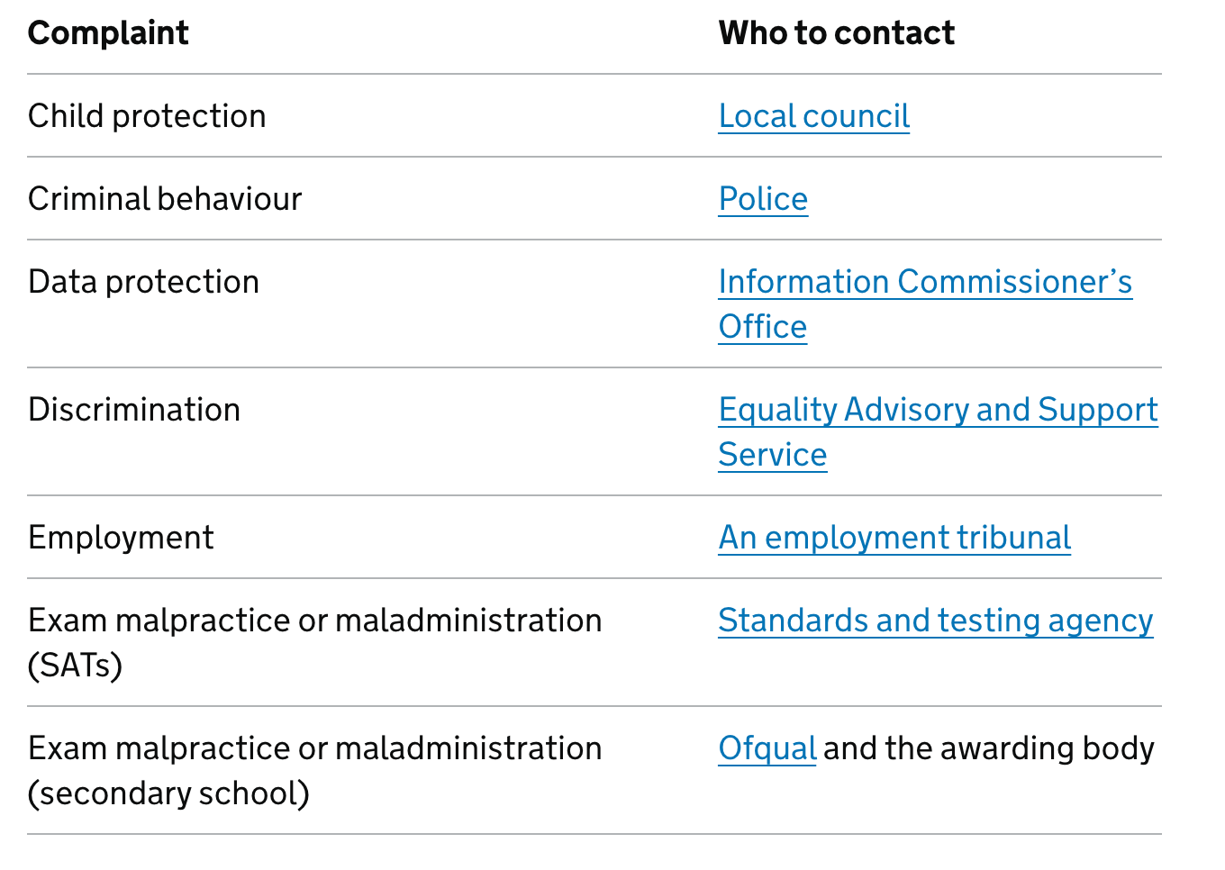

Responsibilities

The Headteacher has overall responsibility for the maintenance and operation of this policy.

The Headteacher will maintain a record of concerns raised and the outcome (but in a form which does not endanger your confidentiality).

Low Level Concerns

Refresh Education is committed to addressing low-level concerns raised about staff in a prompt and effective manner. We understand the importance of creating a supportive environment where all members of our team feel valued and respected.

To address such concerns, we have implemented accessible forms within the school that allow staff to express their observations and feedback.
These forms serve as a confidential platform for staff to communicate their concerns, ensuring that each matter is handled with sensitivity and discretion.

Our DSL (s) will review and assess each concern raised, taking appropriate action to address the issues in a fair and transparent manner.

By fostering open communication and accountability, Refresh Education aims to uphold our standards of professionalism and promote a positive working environment for all staff members.

Concerns raised through the forms provided within the school will be addressed with the utmost seriousness and consideration for the well-being of all individuals involved.

Should these concerns meet the threshold for Safeguarding or Prevent, Refresh Education will handle them in accordance with the appropriate policies and procedures outlined in our safeguarding and Prevent frameworks. These policies ensure that any issues related to the safety and welfare of students or staff are managed with the highest level of care, urgency, and adherence to legal requirements.

Our commitment to Safeguarding and Prevent underscores our dedication to creating a safe and supportive environment for everyone within the school community

This policy should be read in conjunction with the following policies:
- Safeguarding Policy
- Staff handbook
- Equality & diversity policy
- Complaints policy

